Teachig staff
Kooba P.G. College, Dariyapur Newada, Azamgarh

S. No. | Designatio n | Name | Date of Birth | Specializaition in Subject | Address | Mobile Number/Whats app No: | Publication (Writer/Editor of Books) Write  number only | Research and Academic Contibution | Photograph
1 | Professor & Principal | Abhimanyu Yadav | 5/5/1971 | Chemistry | Kooba PH College Dariyapur Newada Azamgah | 9415449435 | 1 | 20 | 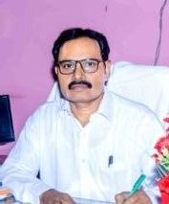
Department of Hindi
2 | Professor | Dr. Devendra Pratap Singh | 12/31/1964 | Hindi | Vill-Khankah, Post- Saraimeer, Distt- Azamgarh, Uttar Pradesh - 276305 | 9838807937 | 3 | 12 | 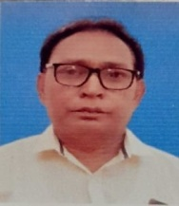
3 | Assistant Professor | Dr. Radheshyam Madhukar | 9/10/1979 | Hindi | Village and Post - Bhala Khurd, District-Ghazipur, Uttar Pradesh - 275204 | 9918158175 | 0 | 2
4 | Assistant Professor | Dr. Surendra Pandey | 2/12/1979 | Hindi | Village- Khutahi, Post-daulatnagar District-Ghazipur Uttar Pradesh - 275204 | 09451173404 | 3 | 80 | 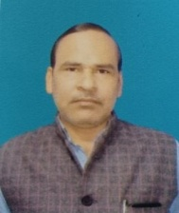
5 | Assistant Professor | Pankaj | 7/10/1978 | Hindi | Kooba p.g college dariyapur nawada azamgarh |  |  | 04 | 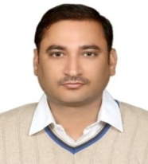
Department of Sociology
 | Assistant Pr | RITESH VERMA | 7/14/1979 | Urban sociology | KUBA PG COLLEGE | 8887699288 | 1 |  | 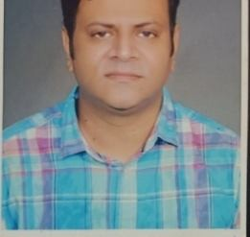
 | Assistant  Professor | Shailendra Pratap  Raghuvanshi | 12/30/1971 | Sociology | Kooba PG college  Dariyapur newada Azamgarh U P | 9455471884 | 0 | 10 | 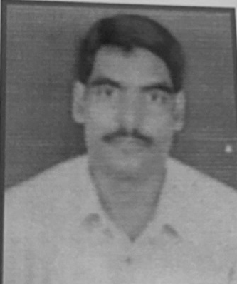
 | Assistant Professor | PANKAJ KUMAR SINGH | 8/22/1978 | SOCIOLOGY | SH 5/69-4-K LAXMANPUR SHIVPUR VARANASI 221003 | 9451108377 | 0 | 2 | 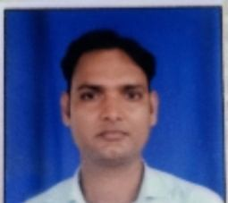

 | Assistant Professor | Dr. Amar Kant Singh | 7/15/1975 | Sociology | Village Heerapur Machahati, Post Bardiha, Distt.  Jaunpur | 8382875979  9415765518 |  | 8 | 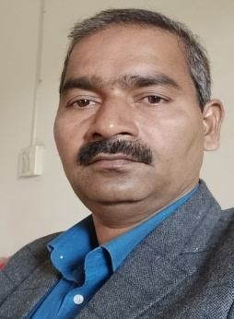
 | Assistant Professor | Dr.Rajeev Kumar Tripathi | 9/10/1980 | Sociology | Vill-Post- Jalalabad,Distt- Ghazipur 275202 | 9452845975 | 1 | Journal- 6,workshop- 2,paper present- 16 | 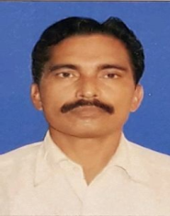
Department of Geography
6 | Assistant Professor | Dr. Rajan Pandey
7 | Assistant Pr | Kamindar | 2/9/1988 | Geography | Vill kusumhi post brahmanpur dist jaunpur | 6307424949 | 0 | 3 | 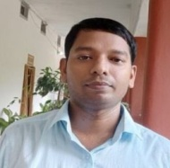
8 | Assistant Pr | BABITA SHUKLA | 3/28/1990 | Geographical Thought, Indian Geography, Geomorpholog y etc. | Jaunpur | 8756865033 | 7 | Proceedings
9 | Assistant Pr | Dr. Digvijay Singh | 1/1/1976 | Geography | Vill- Ganipur Dagraha, Post- Tilkhara Pura Dani, District - Azamgarh, Uttar Pradesh - 276203 | 9792857907 | 0 | 2 | 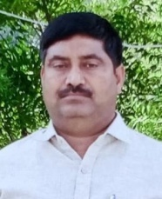
10 | Assistant Pr | Dr.Ashok Kumar Singh | 9/1/1973 | Geography | Vill-Rovapar,Post- Dariyapur Newada Azamgarh | 9565268944 | No | Paper-6 Seminar-8
Psychology
11 | Assistant Professor | Dr. Kumkum Singh | 7/15/1989 | Psychology | Department of Psychology, Kooba  P. G. college, Dariyapur, Nevada, Azamgarh, U.P | 9454915523 | 0 | 12 | 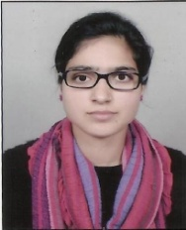
Sanskrit

12 | Assistant Professor | Dr.Akhilesh Kumar Patel | 7/30/1987 | Sanskrit | Village -Rasulaha Post-Pariyat District- Jaunpur U.P. | 8574027300 | NA | 10 | 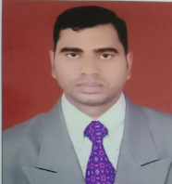
Ancient History
13 | Assistant Professor | Deepak Kumar
English
14 | Assistant Pr | Satyendra Prajapati | 7/10/1995 | English (Indian and World Literatures) | 222/141  Karelabagh Gaon, Prayagraj, Uttar Pradesh- 211016 | 9198579879 | 0 | 5
Economics
15 | Assistant Pr | Pankaj kumar | 8/20/1989 | Economics | Village dhanethu chuppepur post Lagadhar pur jaunpur | 8127941636 | NA | NA
 | Associate Professor | Dr. Tarun Kumar Dwivedi | 8/4/1970 | Economics | Pandeypur, Varanasi | 9415686502 | 7 | 125 | 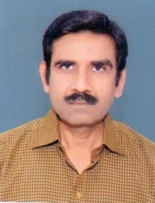
16 | Assitant Professor | Dr. Ajay Vikram Singh
Military Science
17 | Assistant Pr | Dr Rana Pratap Singh | 1/22/1981 | Military Science |  | 9838398618 |  | 06
Education Department
18 | Assistant Pr | BIKESH KUMAR GUPTA | 7/5/1983 | Education | Vill-mandupur.post- sgrpg college dobhi dist-jaunpur 222149 | 8318904348 | No | No | 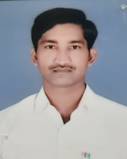
Home Science
19 | Assitant Professor | Smt. Kanchana Srivastava
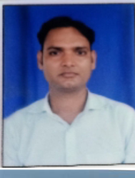
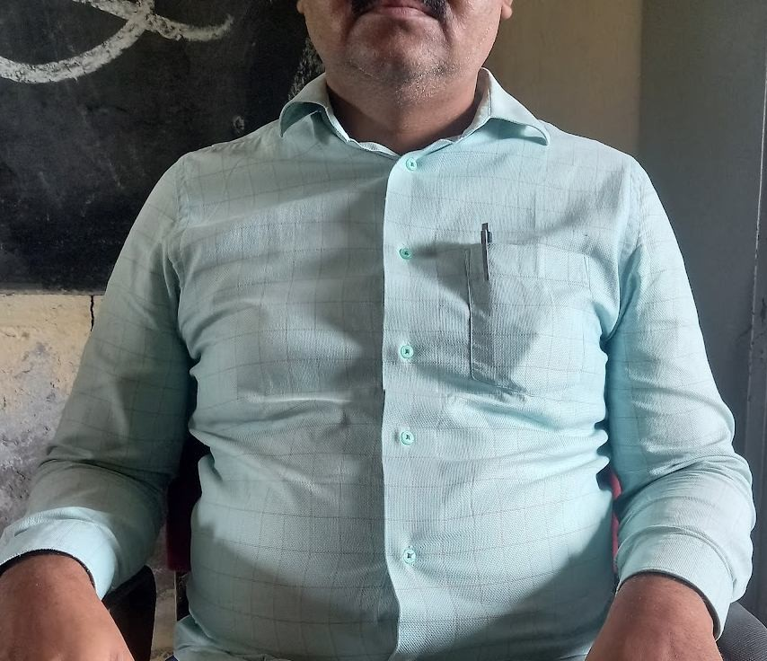

20 | Assistant Professor | Banadana Yadav
Department of Commerce
21 | Assistant Pr | Dr Ashok Kumar Mishra | 3/5/1979 | Commerce | Kuba mahavidyalay Dariyapur Newada azamgarh (UP) | 9451119439 | 2 | 7
22 | Assistant Pr | Dr.Dinesh Kumar  Yadav | 3/5/1981 | Commerce | Village:Beharadar  Post.SGR COLLEGE DOBHI DIST:JAUNPUR 222149 | 8299534795 | No | Journal | 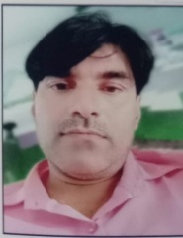
23 | Assistant Pr | Dr.Ajeet Singh | 1/2/1978 | Commerce | Vill&post-Amhit, kerakat, Jaunpur | 9984062495 | 3 | Journal/, seminar | 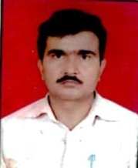
Deapartment of Science
24 | Assistant Pr | Dr Shashi Bhushan Tiwari | 8/12/1978 | Mathematics | Village sheradih  ,post sheradih, dist ballia u p | 9451065001 | 4p | Paper 5,  seminar 4
25 | Assistant Pr | Dr.Santosh Kumar Upadhyay | 7/9/1978 | Botany | Kaptanganj,Terhi, Azamgarh | 9721874607
26 | Assistant Pr | Shri Yashpal Singh | 11/10/1979 | Physics | Vill.-Kabilaha, Post.- Safipur, Dist. - Azamgarh U.P.  276202 | 9784502674 | Nill |  | 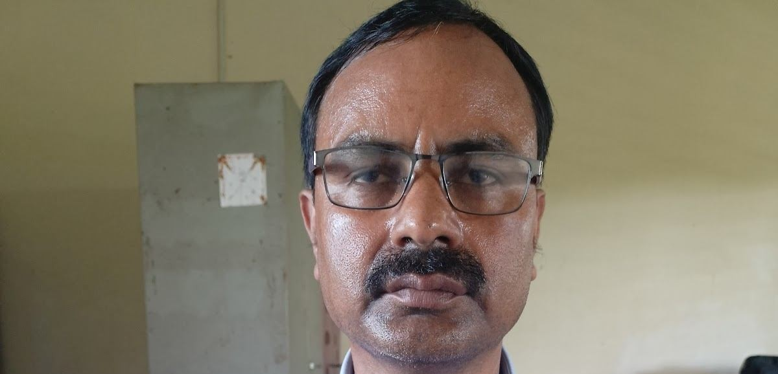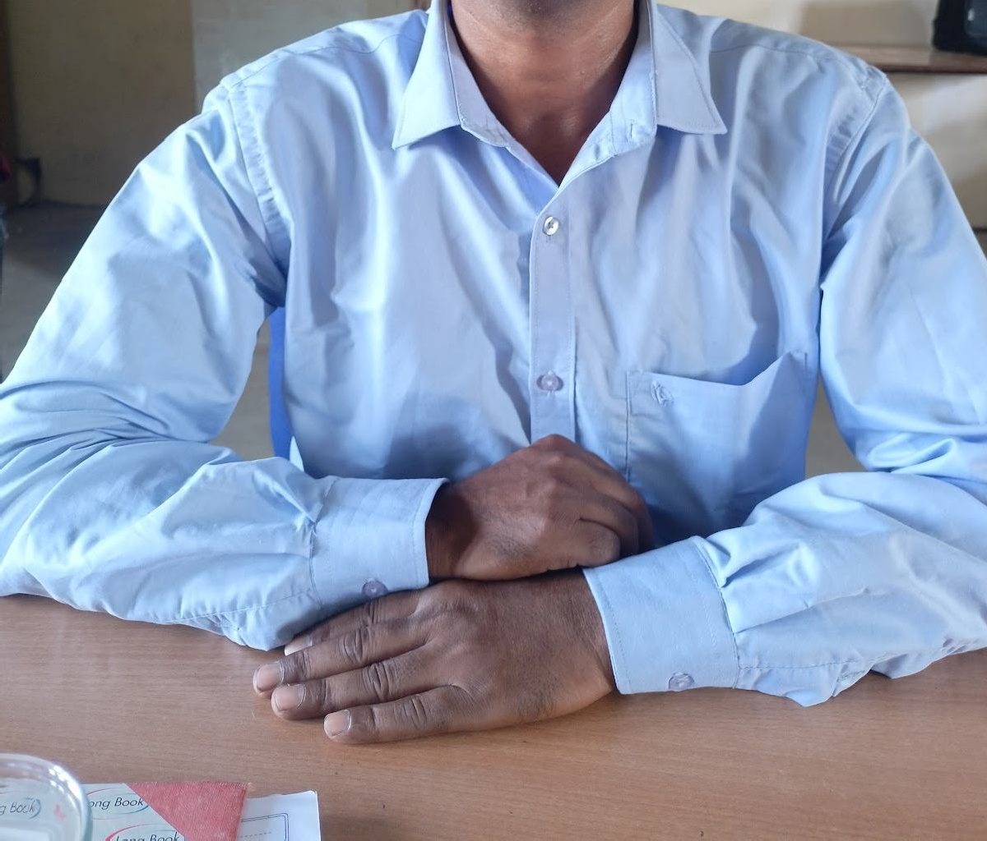
27 | Professor | Abhimanyu Yadav | 5/5/1971 | Chemistry | Kooba PH College Dariyapur Newada Azamgah | 9415449435 | 1 | 20 | 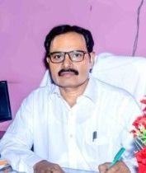
28 | Assistant Pr | Deepak Varma | 7/10/1989 | Zoology | Vill. Balua Vijaipur, Post. Karra college, Dobhi, Jaunpur | 9506795065 |  | 3 international seminar, 1national seminar, 1 workshop, research paper 6 | 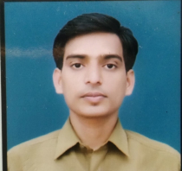

29 | Assistant Pr | Punit Kumar Srivastava | 7/1/1974 | Zoology | 56 Sharma City  takrohi sec 11 Indira Nagar Lucknow | 9919441980 | 10 | 04 | 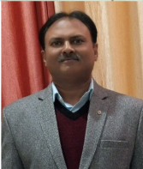
30 | Assistant Pr | SANGAM KUMAR | 7/11/1996 | ZOOLOGY | VILLAGE - KISHUNPUR URF MANIKPUR  POST- KANJAHIT, DISTRICT- AZAMGARH 276201 | +917860666671 |  | 4-Workshop, 6- International Seminar, 11- National Seminar, 5 - Research Paper, 1- Book
None Teaching & office Staff

S.No. | Name | Contact Number | Photograph
1 | Shree Pramesh Pratap Singh | 9792555659
2 | Shree Arun Kumar Singh | 8400170476
3 | Shree Brijesh Singh | 9305969218
4 | Shree Sushil Kumar Pandey | 6386628484
5 | ShreeSant Prasad Yadav | 9839448580
6 | Smt. Madhurbala Singh | 7355320135
7 | Shree Chhedi Lal Yadav | 8948441522
8 | Shree Santosh Kumar Singh | 9453361719
9 | Shree Jang Bahadur singh | 9984643187
10 | Shree Saltan Ram | 9648651830
11 | Shree Nazruddin | 8303897247
12 | Shree Somaru | 7800812012
13 | Shree Rakesh Verma | 8840968673
14 | Shree Vishal Verma | 9648479640

